ABSTRACT

For more residents to feel safe bicycling around Struthers, there is a need for bicycling infrastructure in the form of bike lanes and designated routes. The main regional throughfare in Struthers, 616, requires special attention, being one of the least bike-friendly streets in the city while also cleaving it in half, and being the only way for most residents to get to Struthers’s most important site for recreational bicycling, Stavich Bike Trail.

Introduction

The growing accessibility of ebikes and other electrified single-passenger vehicles (scooters, EUCs, etcetera) means that navigating the hills of Struthers without a car is more feasible than ever. While the street network of Struthers is mostly made up of calm, low speed side streets good for bicycling, 616 and a few other stretches around the city pose issues for complete, safe connectivity. I will be proposing a bicycling network made up of bike lanes, paths, and signed routes to remedy this. Most of this network could function independently of its other parts, but I will be grouping certain projects together that would not achieve their greatest impact alone. This means that the whole network need not be built all at once, but the eventual completion of a holistic network would make Struthers the gold standard for bike navigation in Ohio.

Projects

Before we dive into the possible projects, here is a rough map of the proposed network. Green is 616; orange is bike lanes and protected bike paths; purple is signed bike routes that also have more focused improvements when intersecting with bike lanes and paths.

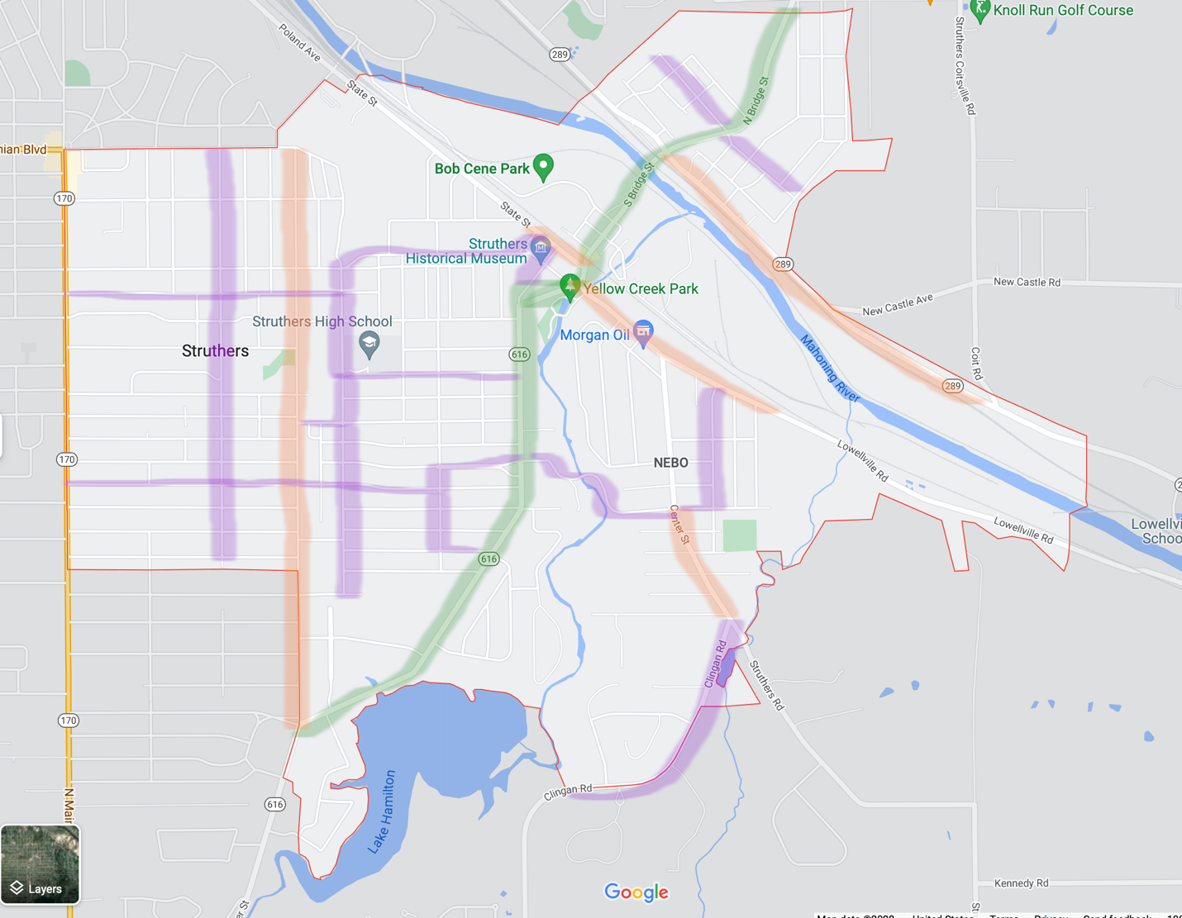

Route 616

This project is the keystone of the entire network. It leads to Stavich Bike Trail, must be taken or crossed to get to school for many residents, connects all the other projects and may connect to riverfront trails and amenities in the future. The success of this project would be seen in people biking to the Stavich Bike Trail, kids biking to school, and people of all ages biking to get around.

Starting at the intersection with 5th St, 5 foot wide bike lanes would begin on both sides of the street, in the direction of car traffic. Bollards would be placed to separate bike and car lanes, especially south of Smithfield St where driveways are farther apart.

Going north, a crossing-by-button feature, or even a 4-way stop, should be placed at Omar, Iroquois, and 616 so that residents of the neighborhood between 616 and Yellow Creek may cross safely. In this example and in all following examples, crossing buttons may be used by pedestrians as well.

Bicyclists can utilize the existing signalized intersection at Overlook, Wetmore, and 616 to exit toward 5th St or Yellow Creek Park. Left turn buttons may be useful here, especially to turn from 616 onto Overlook or Wetmore. These would turn the main signal red in both directions, allowing the bicyclist to turn directly from the bike lane without entering the main lane. Signs warning right-turning cars to yield to bikes are even more important.

Continuing north, an on-demand traffic signal or 3-way stop would be created at Morrison and 616 to facilitate access to the high school and middle school.

At Poland and S Bridge, by Parkside Church, the northbound bike lane should end (this is also where the southbound lane begins), at which point bicyclists move into the straight lane, to continue down Poland Ave.

Upon reaching the bottom of Poland Ave, cyclists would turn right onto State St, where bike lanes resume. Northbound this may be a painted lane that separates the traffic/left turn lane from the parking/right turn lane. Southbound cyclists may benefit from a painted square near the middle of the intersection of State and Poland where: 1. motorists can be warned that bikes may enter their lane to turn left and 2. cyclists can wait to turn left without impeding traffic. Where I mean that this should be placed is represented by the green square below.

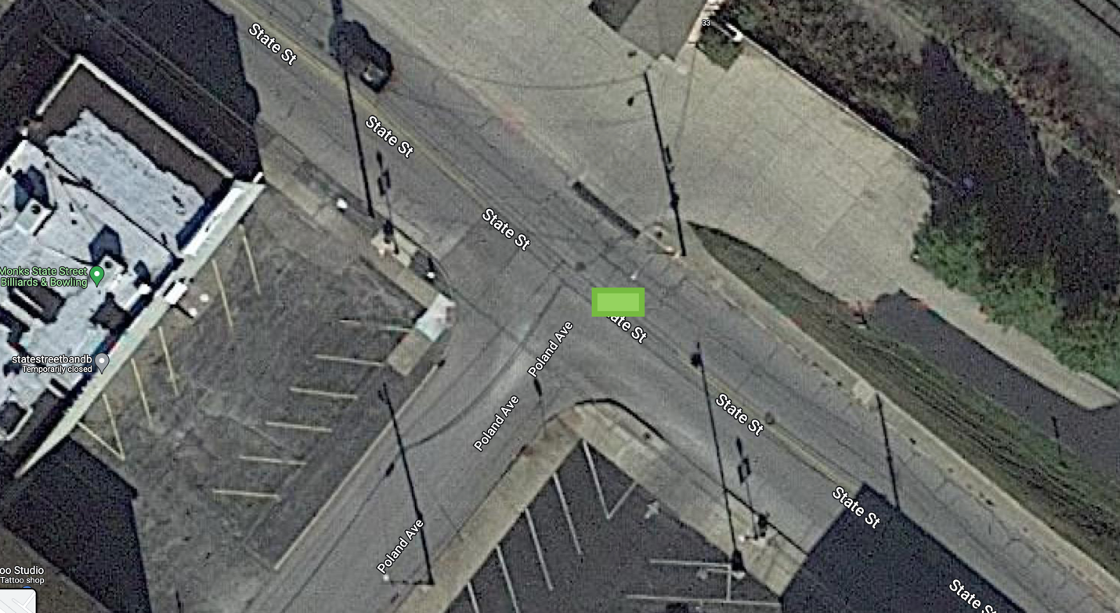

The bike lanes should then turn left onto S Bridge St, following a dotted line through the intersection. They would proceed normally up to N Bridge and Broad, where there is a sign telling right-turning drivers to yield to bikes. The bridge and much of the North Side could have the bike lanes separated by bollards given the lack of places to turn. Frank and 616 should have an on-demand crossing signal. Both lanes end at N Bridge and upper Mickler Park.

Estimated Cost: approx. $110k

5th Street and Parallels

This project takes advantage of the extraordinary width of 5th Street. This a popular street that provides access to schools, stores, and services, so it makes sense both to give cyclists a safer way to get all these places, and to make it easier on drivers who won’t have to worry about giving enough room while passing cyclists. Success would mean seeing more people taking a bike to get groceries and more kids taking bikes to school.

At up to 36 feet wide in some spots, there is plenty of space to work with. Starting from its south end, 5 feet bike lanes would be placed on the edges of the street, going in the direction of traffic. Where wide enough there would be an additional line between the bike lane and the street. In select areas, namely in front of the plaza, in front of the middle school, and in front of 5th Street Park, barriers can be installed in the gap between these two lines to enhance protection from traffic and provide visual appeal.* These lanes may either be taken all the way to Midlothian, or stop just short of it before the block between Lincoln and Midlothian where street parking is more common.

There are fewer “main entry points” or bottlenecks along 5th St compared to 616, so adding crossing buttons is less feasible. Luckily, there are two streets running parallel to each side of 5th Street. By putting up simple “bike route” signs on Garfield and on 8th, it can be made clear that you don’t need to turn left across 5th during busy hour, especially if you don’t need to cross the street to reach your destination.

Estimated Cost: approx. $8k

Broad Street

Key to getting to the Stavich Bike Trail from Struthers, this road already has “share the road” symbols painted on it. The completion of this project would mean people could feel more secure in biking straight to the trailhead, instead of driving to it with their bikes.

The road starts off fairly wide at its intersection with 616 but narrows as it approaches the trailhead the most sensible solution seems to be a two-way protected* cycle path. This would start at Broad and 616 on the side of the road facing the river, requiring a signal upgrade to let bikes turn onto and from 616 without conflicting with the path of cars. The path could then be carved out of the existing, wider road up until about the intersection with New Castle Rd, at which point new pavement on the open south side of the road would be required. The path would end upon reaching the trailhead, and normal share-the-road symbols would continue down Broad. Bollards* would proceed down the entire path, separating it from the road

Estimated Cost: approx. $15k
East-West Connectors

We are in a lot of ways a vertical city, but that doesn’t mean that no one ever needs to move horizontally. These improvements should help cyclists route around the city on streets that are already safe. The idea behind this isn’t to restrict the movement of bikes to these routes, but to instead make it easier to plan a calm and direct route to their destinations. For example, to get from W Omar to Iroquois today, one of the most unintimidating routes would probably turn onto 8th, then onto Geneva, continue straight onto Helena, turn onto Argonne, onto E Omar then continue onto Iroquois. It just makes less sense to have to turn at the bottom of W Omar, or turn from Helena onto Poland Ave. This principle is reflected in the below “bike route” suggestions, and on the map above.

What I am imagining when I say “bike route” is that the given street would have signs every so often saying just that—(BIKE ROUTE), with helpful directions below—to (street/landmark/neighborhood), that help riders use the network as intended. As an example, a sign on Helena eastbound appraoching Argonne might look like this:

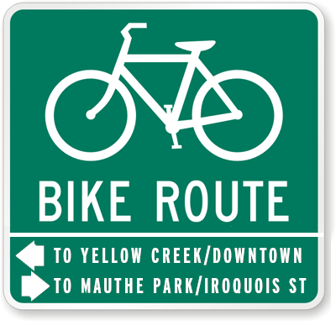

The first marked street is Maplewood from Youngstown-Poland to Garfield. This lies between the two busier streets of Sexton and Elm, and maintains the side-street connectivity of both despite being less trodden. Ending at Garfield would direct students to cross Sexton at an existing 4-way stop. You could also turn down the 8th St “bike route” included in the 5th St project to get to…

Geneva. Continuing as Helena on the other side of 5th, this is the only street in the immediate area that is unbroken across 5th, and so it would be the perfect place to funnel bike traffic into and create a safe crossing over 5th. A 4-way stop would be sufficient, but visibility is good enough here that a sign and crosswalk may good enough. Helena would continue as a bike route until Argonne, at which point it splits and goes down Overlook for cyclists headed to Yellow Creek, and down Omar for cyclists headed to the Hopewell neighborhood (and of course, local bike traffic continues to use whatever streets it needs to).

Morrison as a bike route would make it clear (in accordance with the above 616 plan) that Morrison is the best place in the area to turn onto 616. Elm from Garfield to State is the busiest street I’ve listed in this section, but it would continue the Maplewood route towards town and formally connect Coke Alley to the network. Some share-the-road symbols might be helpful on this one.

Frank/Highland signage would funnel intra-Northside traffic into a safe 616 crossing, and provide an additional way to turn onto 616 to go into town.

Estimated Cost: approx. $3k

Nebo-Hamilton Woods Arterial

This would connect Nebo and Hamilton Woods to the rest of the network, while also welcoming Poland and other communities into the city.

Lowellville Rd would have a semi-protected* bike lane (with space given for intersections and driveways) starting at Narcissa and extending to Bridge St. With some determination, widened sidewalks becoming mixed-use paths also seems possible, especially from Center to Bridge. I am not sure if bike lanes are feasible on Bridge between Lowellville Rd and State St, but I think either a synced light or an all-way stop would make the intersection of Lowellville and Bridge nicer for both cars, bikes, and pedestrians. An all-way stop at Perry and Lowellville could also be helpful in allowing the neighborhood west of Center St access to the network, especially considering the problem presented in the following paragraph.

The other connection on Lowellville Rd would occur at Prospect, where there is a signed bike route extending to and taking a right onto Katherine. Upon reaching the intersection of Katherine/Wetmore/Center, bicyclists may continue left onto Center where there are painted bike lanes on each side: headed south, and coming north. This routing is a bit out of the way, but it seems necessary to avoid the busy, long, and narrow climb up Center St from downtown, along with the runaway rush down it (this would also make it completely unnecessary to introduce another all-way stop at Center and Lowellville, yay!).

Center Street’s bike lanes end upon reaching Clingan, when the road becomes too narrow for lanes, but where bike route and share-the-road reminders may be placed to encourage bike traffic from along this road (here, with determination and resident approval, there is also an incredible amount of space for a wide, mixed-use sidewalk for both leisurely strolls and welcoming Hamilton Woods and Poland residents into town).

Estimated Cost: approx. $10k

Wetmore

This is somewhere where it really seems like there should be a great big path, fit to attract riders for the beautiful surroundings despite the inevitable hill. However, this doesn’t really seem within reach, given the narrowness of the road, and the closeness of the terrain. Some elevated crosswalks, as I have suggested before, or simple speed humps, may be what is called for here. These should slow cars down, all the while performing their primary purpose of making it easier to cross the road, and in turn create a more ideal environment to cycle through. All of Wetmore should be designated a bike route as a natural bridge between the rest of the network.

Estimated Cost: approx. $7k

Estimated total cost of network: approx. $150k

Funding

The Safe Streets and Roads for All federal program was created as a result of the recent infrastructure bill, and for the most part it seems like the best way to get funding for a large-scale overhaul like this. It will be giving out grants for the next 5 years, and it defines most expenses which are taken to improve roadway safety as a valid use of grant money. The one issue with this that makes this project seem out-of-line with the program’s goals, is that it is too small scale. I have only skimmed the program’s frequently asked questions (https://www.transportation.gov/grants/ss4a/faqs) but there is the indication that, while no hard minimum is in place, they anticipate that the lowest amount given for implementation of a project will be 5 million dollars. This, along with the fund matching requirement of 20 percent (makes 1 million, a significant portion of the city budget), makes me question if this is a feasible source of funding for this kind of project. It might work with all other street improvements bundled up into it. The parameters of the program specify that an “Action Plan” for reducing serious injury and death from traffic causes must be first developed, either independently, or with the support of an SS4A action plan grant; this means that improvements focused on pedestrians and cars would also be present in the grant application. The deadline for application during this financial year is September 15th.

Appendix

*Barriers/lane protectors
With regard to what exactly should be “protecting” the bikes lanes, it may seem the most cost effective to throw up a bunch of plastic traffic delineator posts, as they are called, as these are used in many other cities and can be easily replaced when needed, running only about $20 a piece. However, another option caught my eye while researching this topic. I came across an article describing an idea a group called WeClaim had for a recycled lane delineator, one that fit an old tire into a shape that can be bolted to the asphalt and also has room for a plant! While these cannot truly protect, as in stop, a car, they may be just as effective as plastic delineators at separating the street. Depending on the sources of old tires available and how you figure labor costs, they may also be cheaper while at the same time improving the esthetic quality of the street by introducing greenery into it. Here is the article to see more: https://www.triathlete.com/culture/bike-barrier-how-old-tires-will-save-cyclists/

Public bike systems
After I had finished this proposal, I saw the news that Mahoning County’s first bike-share system is set to launch soon in downtown Youngstown. The company is launching a fleet of entirely ebikes, which are perfect for negotiating the slopes common in the area. It is likely a while away before this company considers expanding beyond the city of Youngstown, but if it eventually does, it is important to consider that older suburbs such as Struthers have inherently more bike-friendly streets compared to places where the only points of interest are along fast, sprawling corridors like Route 224, Mahoning Ave, or Belmont Ave. Work on the bike network described in this proposal would surely make Struthers target number one for this micromobility project and any in Mahoning County in the future. Bike-share systems and similar concepts such as those using electric scooters or mopeds, can be a great resource to the communities they are located in by making these vehicles available to residents who have a use for them but do not want to commit to the cost and maintenance of them. Public ebikes in particular can get people where they want to go quickly and painlessly, reduce traffic, and eliminate the upfront financial and physical barriers to begin bicycling all at once. They are often used for both business and pleasure, and have been deployed to great effect to nullify the weight of gravity in similarly hilly Pittsburgh.

Connections to trail that don’t exist (yet)
On the left bank of the Mahoning River, there is at least a good mile of potential space for a riverfront trail. Ideally, coming off the Stavich trail, you would be able to connect to this as the crow flies. The fact that there is a river crossing involved obviously complicates this. But even coming off the bridge there is no clear way to reach the river. There is the existing road past the recycling drop-off, but then we run into the issue of crossing the railroad (if this is a simple fix, then this could be satisfactory). Cene Park occupies much of the area to the west of this, and by the time you clear Cene Park, the entrance to the trail may be far enough away along regular road that many will just want to drive to it (defeating the point?). This section does not have a moral; it is just something I have noticed.

